ST-2 Summary

ST-2 Test Stats | #
Test cases planned for this sprint | 6
Test cases COMPLETED (without errors) | 3 | WHICH FR? | FR 4.2  FR 6.2  FR 6.3
Test cases NOT COMPLETED | 3 | WHY? | FR 4.3: Test Incomplete; Status change functionality not found in UI.  FR 8.1: Results not seen via Moxie front end  FR 8.2: Results not seen via Moxie front end
DEFECTS found | 2 | STATUS: | Open

FR 4.2, 4.3
STP Test Case # ST-2
Requirement Tested: FR-4.2: The system shall flag a weekly report as incomplete if any required field is empty or null.
Build/Release #: v0.1.0_20260304
Determination: SUCCESSFUL

Setup:
1. Open the Chrome browser on Mac OS.
2. Navigate to front-facing Moxie server (http://moxie.cs.oswego.edu:7000/)
3. Log into the system (future feature: Google OAuth).
4. Execute test.

Execution:
1. Navigate to the Worklog form.
2. Leave at least one required field empty (tested with the ‘collaborators’ section left blank).
3. Attempt to submit the report.
4. Return to the Student Home Page.
5. Observe the report status and any system feedback.

Expected Result:
- The system should flag the report as incomplete.
- An error message (e.g., red field highlight) should appear on the empty required field.
- The report should NOT be submittable until all required fields are filled in.

Actual Result:
- The system successfully flagged most required fields as incomplete with visual error feedback.
- The collaborators section did not flag as incomplete when left empty; it allowed submission without it.

Screenshot:
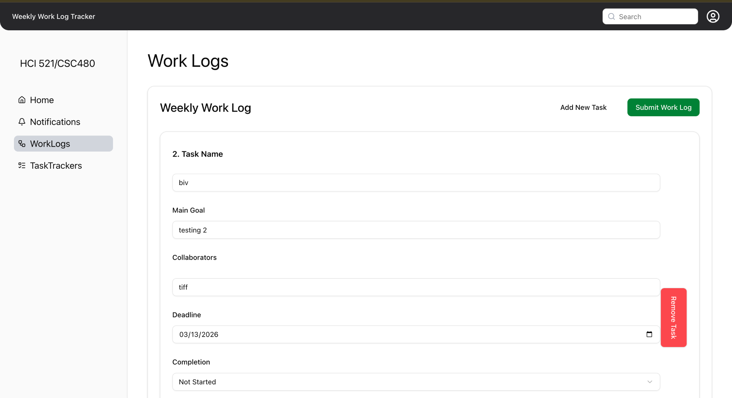
Fig (1.0): There should not be any error message when all fields are filled out.

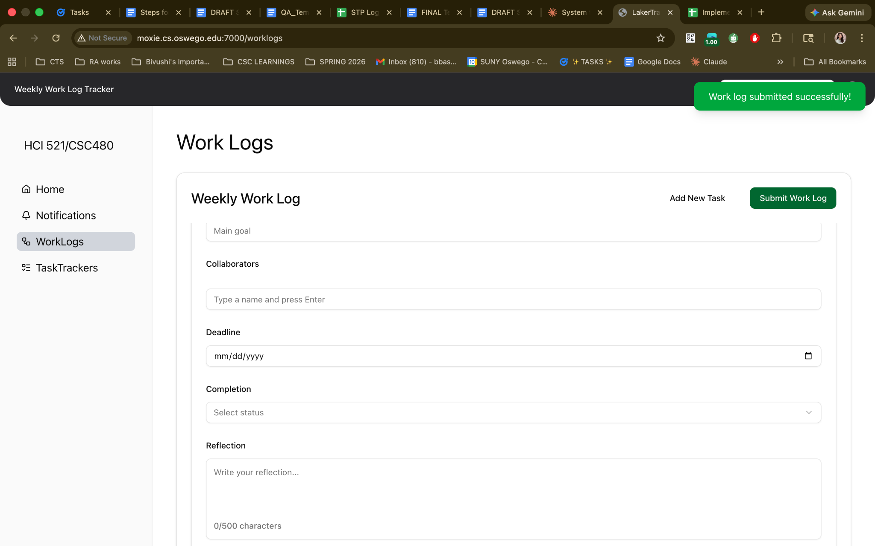

Fig. (1.1): The collaborators section was not flagged as incomplete when left empty; it allowed submission without it.
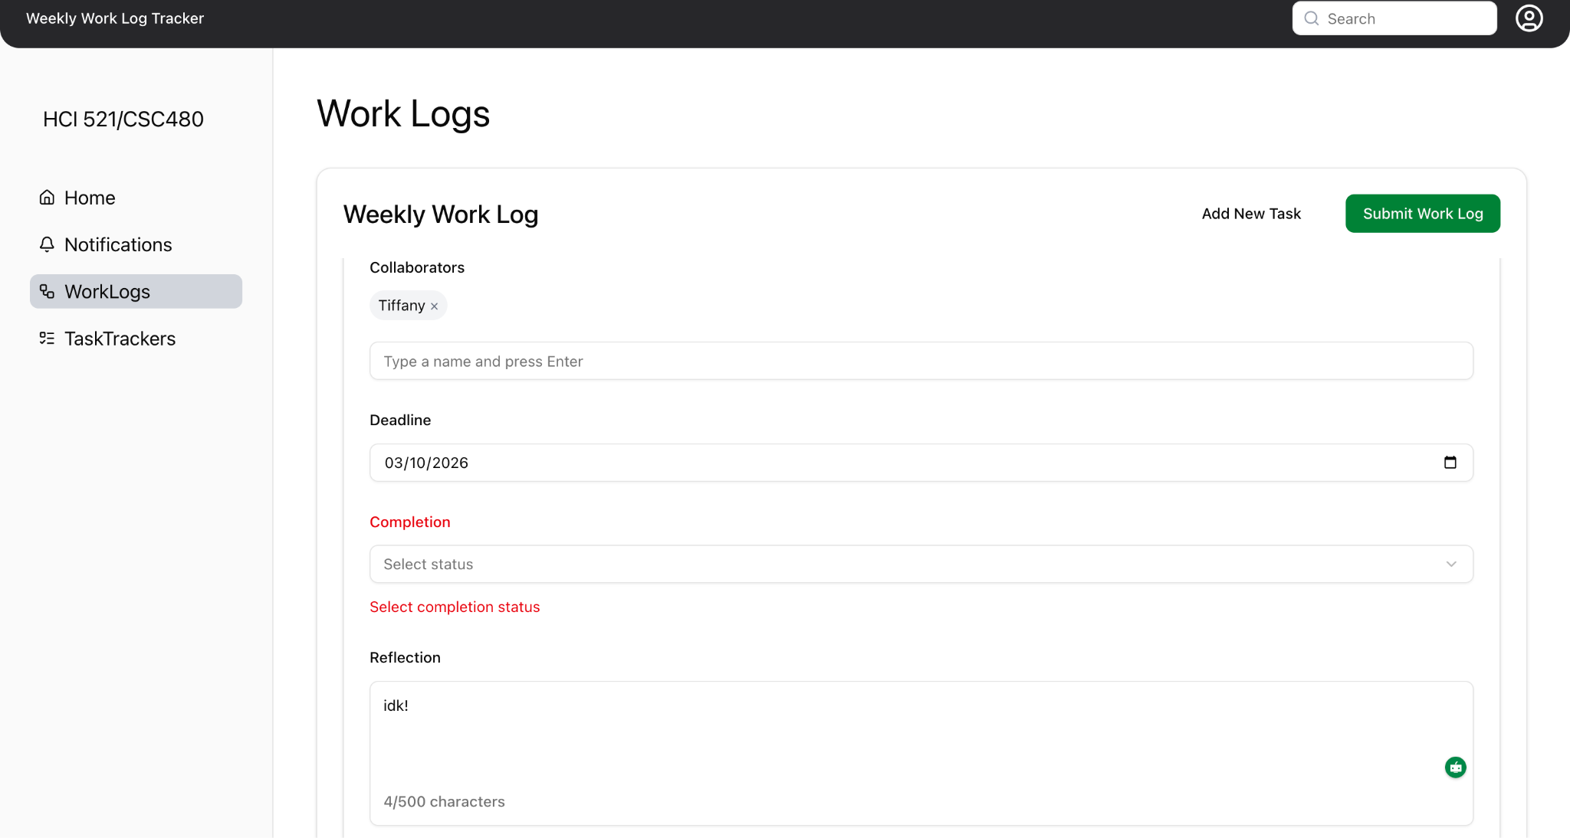
Fig: (1.2) : The system flags the report as incomplete, highlights empty required fields in red, and prevents submission until all required fields are filled in.

STP Test Case # ST-2
Requirement Tested: FR-4.3: The system shall prevent incomplete weekly reports from being marked as complete.
Build/Release #: v0.1.0_20260304
Determination: Test Incomplete; Status change functionality not found in UI.

Setup:
1. Open the Chrome browser on Mac OS.
2. Navigate to front-facing Moxie server (http://moxie.cs.oswego.edu:7000/)
3. Log into the system (future feature: Google OAuth).
4. Execute test.

Execution:
- Navigate to the Home Page and look into the ‘Task Tracker’ section.
- Navigate to the Notifications Page and look into the ‘Task Tracker’ section
- Attempt to change the report status from In Progress to Complete.
- Observe whether the system prevents or allows the status change.

Expected Result:
- The system should prevent the report from being marked as complete.
- A status change option (e.g., dropdown, button) from In Progress → Complete should be blocked or disabled.
- An error or warning message should notify the user the report is incomplete.

Actual Result:
- There is no option available to change or select the report status from In Progress to Complete.
- The only available action is to highlight/copy the current status; no status change functionality exists in the UI.
- Cannot confirm if the system prevents the action because the feature does not appear to be implemented.

Screenshot:
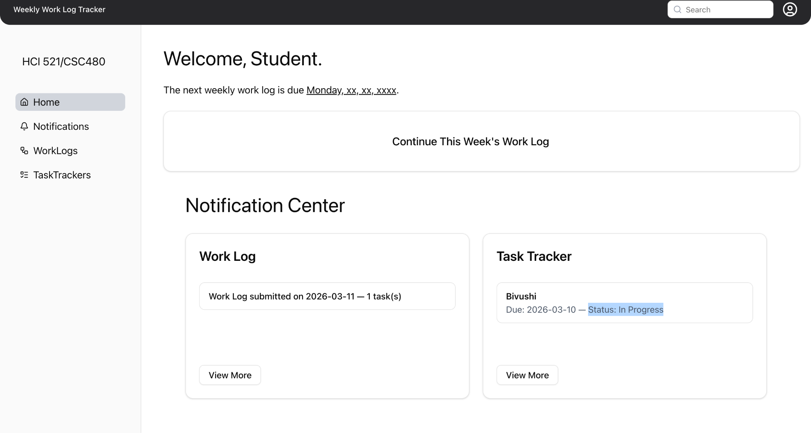

Fig. (2.0): The ‘status’ could only be highlighted and not changed from the ‘Home Page.'

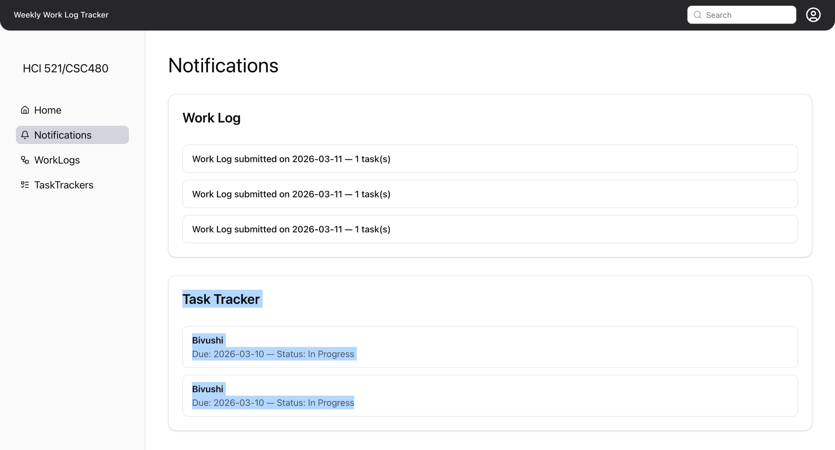
Fig (2.1): The ‘status’ could only be highlighted and not changed from the ‘Notifications Page.'

FR 6.2, 6.3
STP Test Case # ST-2
Requirement Tested: FR-6.2: The system shall continue loading available home page components after a non-critical failure.
Build/Release #: v0.1.0_20260304
Determination: SUCCESSFUL
Setup:
1. Open the Chrome browser on Mac OS.
2. Navigate to front-facing Moxie server (http://moxie.cs.oswego.edu:7000/)
3. Execute test.
Execution:
1. Navigate to the Homepage.
2. Open Developer Tools: Right click any element and select Inspect.
3. Go to the Network Tab: Click the Network tab in the top menu of the panel. 4. Enable Throttling: Locate the dropdown menu that says No throttling near the top right of the network pane.
5. Select Speed Profile: Click the dropdown and each option, such as:
- Fast 4G: Simulates a decent 4G connection.
- Slow 4G: Simulates a poor 4G connection.
- Decent 3G simulation
6. Reload the Page: Refresh the page to see the effect of the throttled speed.
6. Observe the status and any system feedback.

Expected Result:
- The homepage loads for the student even if a non-critical component fails, and the remaining components display normally without preventing page functionality.

Actual Result:
- The system successfully goes through each simulation and works for all cases. All the components were displayed normally.
Screenshot:
Go to network - check “no throttling”
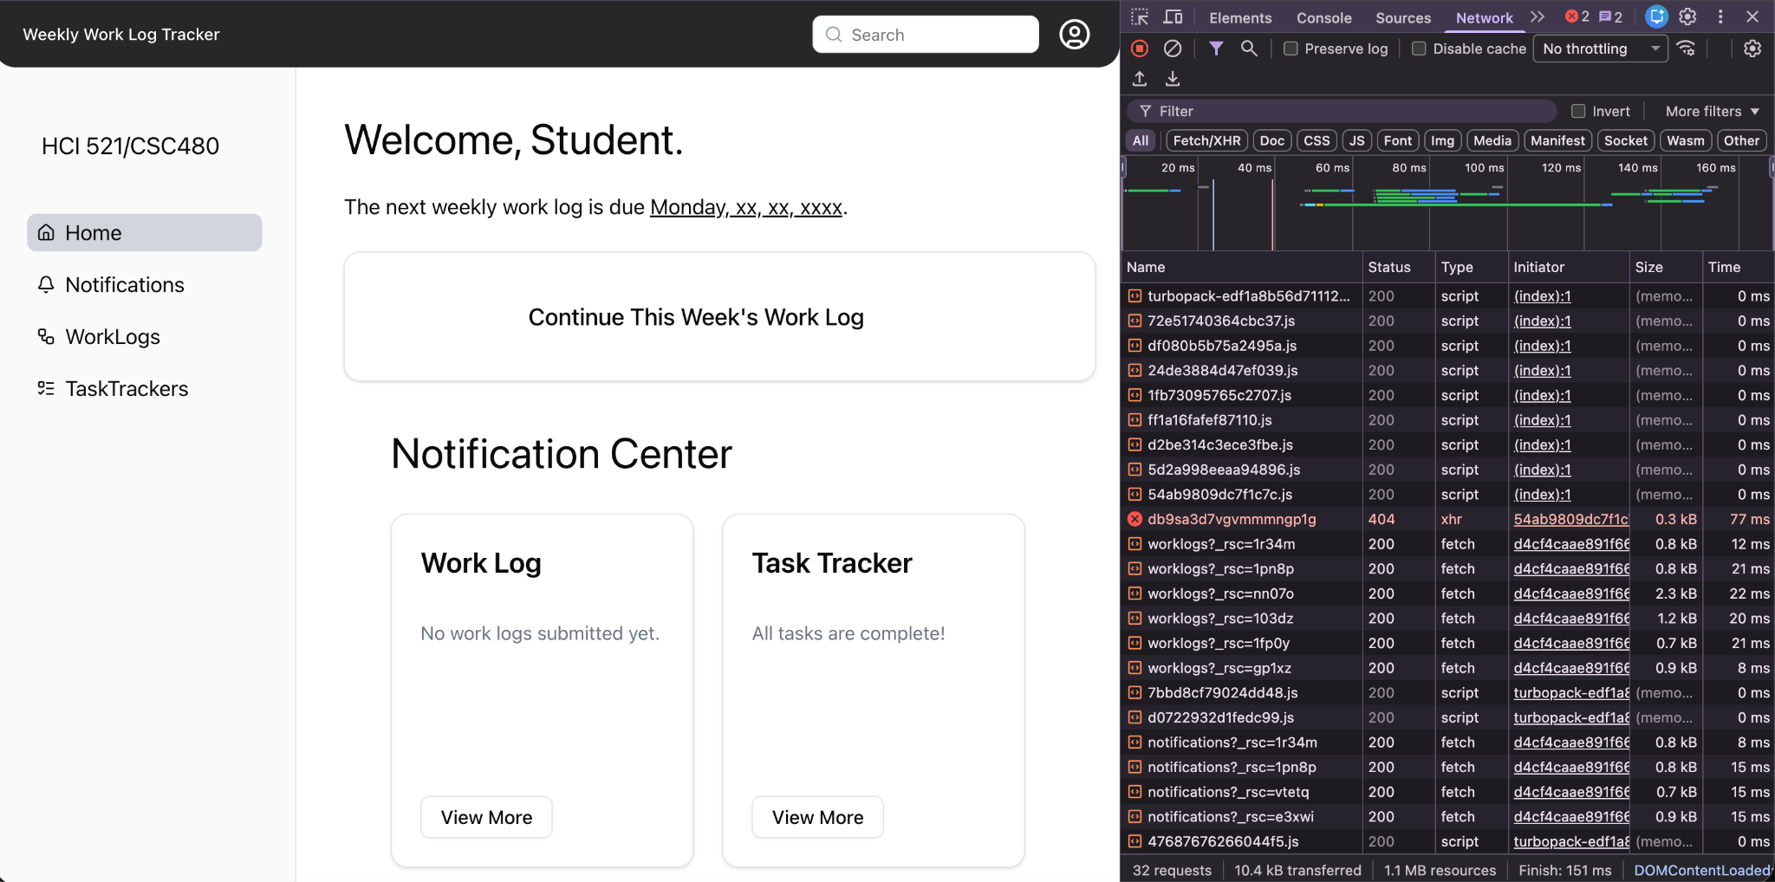

- Fast 4G connection.
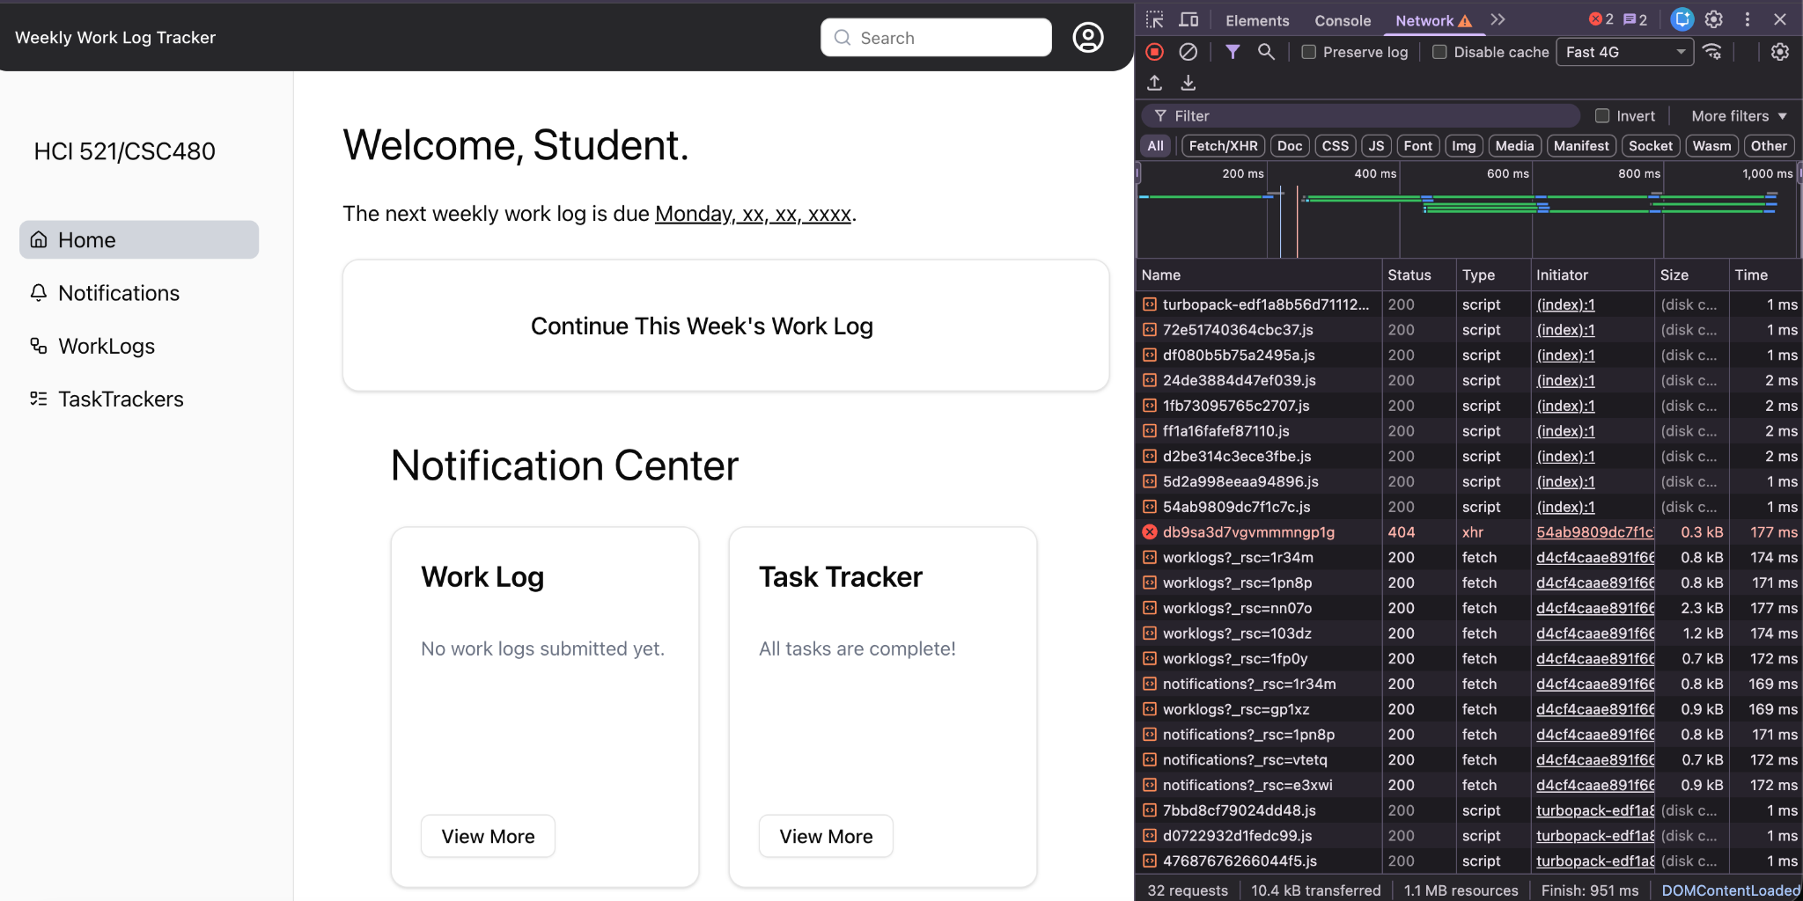
- Slow 4G connection.
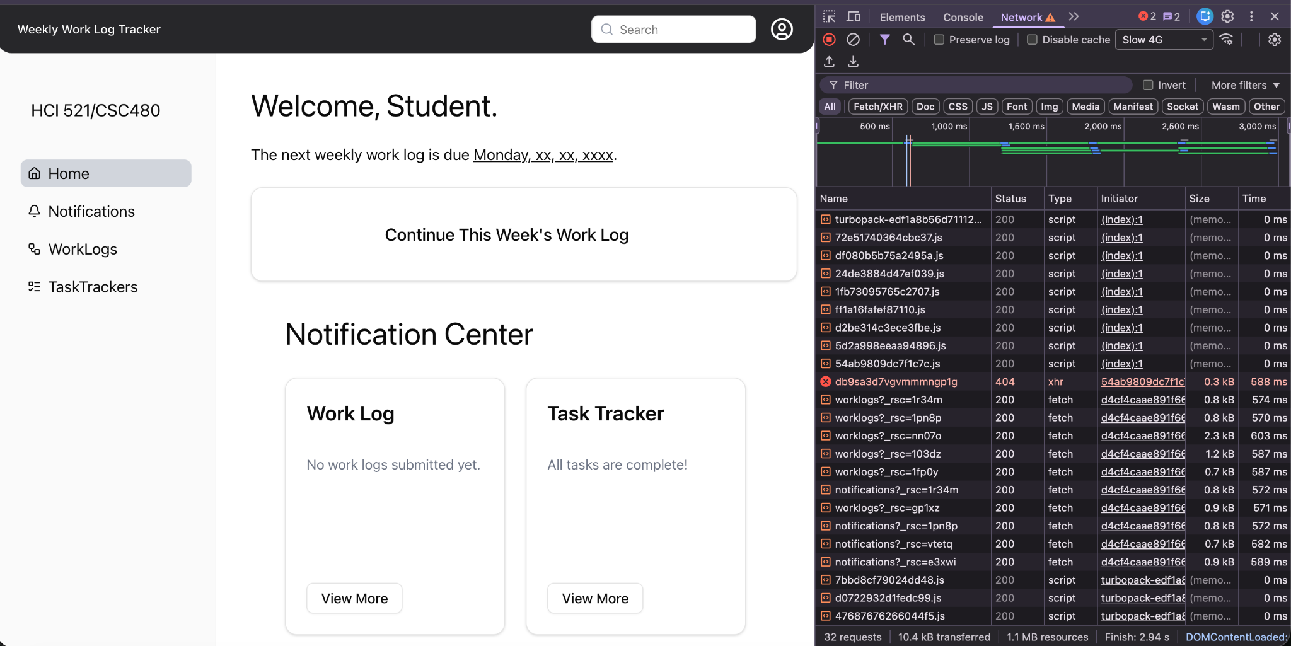

- Decent 3G connection.
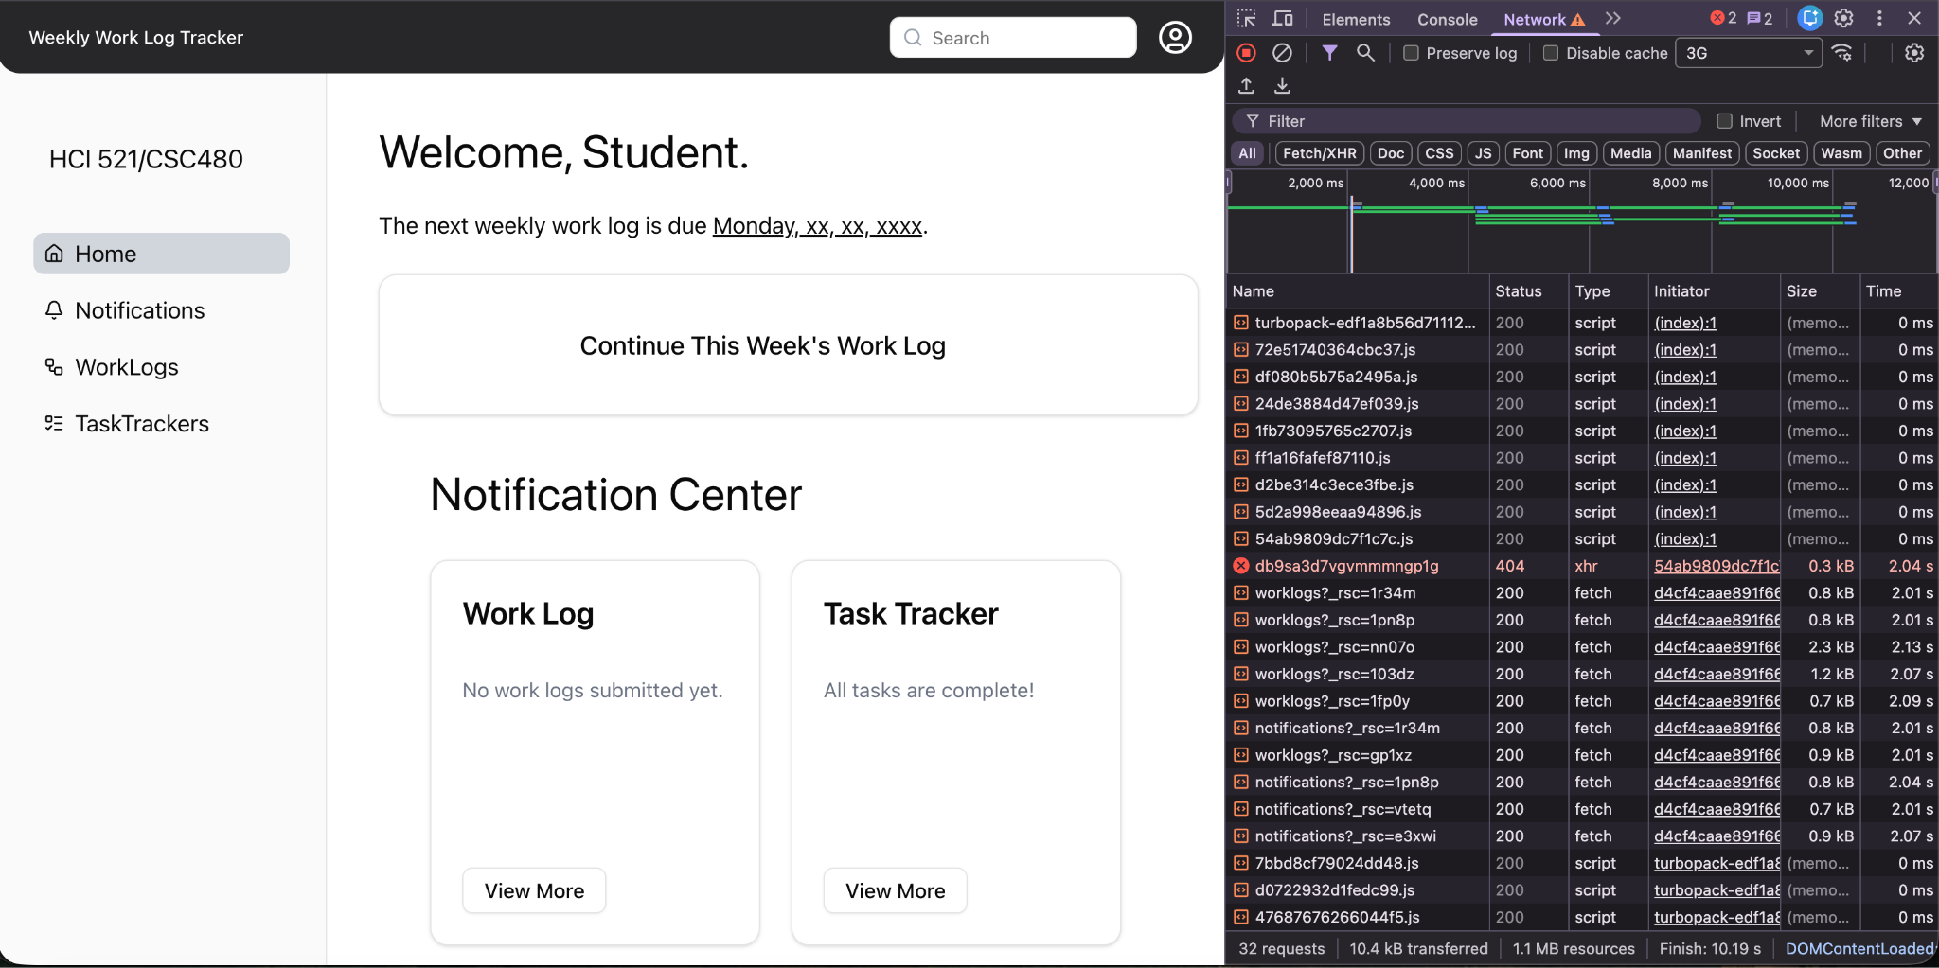

STP Test Case # ST-2
Requirement Tested: FR-6.3: The system shall display an error message when critical home page data cannot be loaded.
Build/Release #: v0.1.0_20260304
Determination: SUCCESSFUL
Setup:
1. Open the Chrome browser on Mac OS.
2. Navigate to front-facing Moxie server (http://moxie.cs.oswego.edu:7000/)
3. Execute test.
Execution:
1. Navigate to the Homepage.
2. Open Developer Tools: Right click any element and select Inspect.
3. Go to the Network Tab: Click the Network tab in the top menu of the panel. 4. Enable Throttling: Locate the dropdown menu that says “No throttling” near the top right.
5. Click the dropdown : Offline- Simulates no internet connection.
6. Reload the Page: Refresh the page to see the effect.
6. Observe if the home page loads and displays an error.
Expected Result:
- If critical home page data cannot be loaded, the system should display a clear error message to the student indicating the issue.
Actual Result:
- The system successfully showed error.

Screenshot:
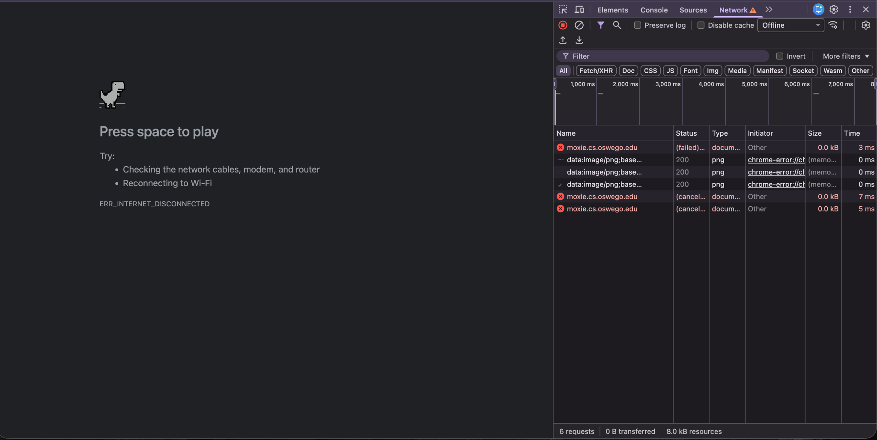

FR 8.1, 8.2
STP Test Case # ST-2
Requirement tested: FR-8.1 The system shall log home page load events.
Build/Release #: v0.1.0_20260304
Determination: UNSUCCESSFUL
Setup:
1. Open the Chrome browser on Windows OS
2. Navigate to front-facing Moxie server
(http://moxie.cs.oswego.edu:7000/)
3. Execute test
Execution:
1. Load the moxie server
2. Inspect if the load event that was triggered (not shown)
Expected Result:
1. A log entry is created each time the home page is loaded. 2. The log has information such as load event triggered, timestamp of the event, and event status
Screenshot:
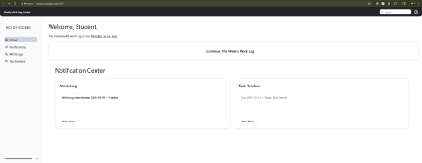

Screenshot 2: Chrome browser on Windows OS with Dev Inspect open
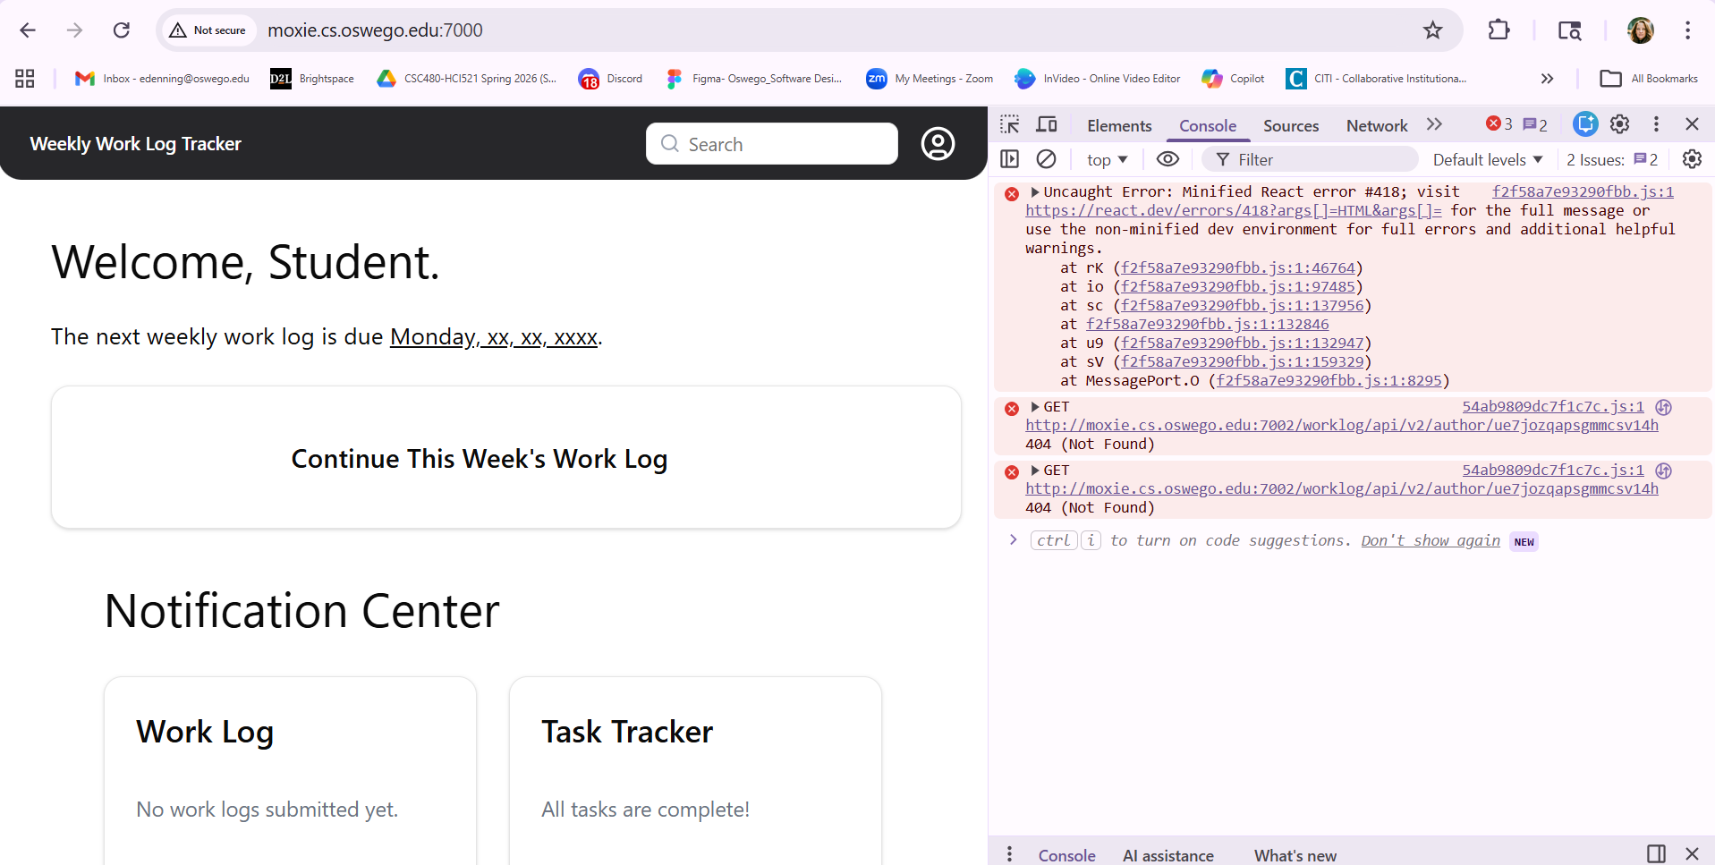

It looks like there was an event created, however, the log did not have information such as load event triggered (unless GET is the event), timestamp of the event, and event status.

STP Test Case # ST-2
Requirement tested: FR-8.2 The system shall log data retrieval failures related to home page loading.
Build/Release #: v0.1.0_20260304
Determination: UNSUCCESSFUL?
Setup:
1. Open Safari browser on MacOS.
2. Navigate to the front-facing Moxie server
(http://moxie.cs.oswego.edu:7000/)
3. Log in as a student user.
4. Generate a notification by adding a task or submitting a report.
Execution:
1. Load the moxie server
2. Turn the wifi off on my laptop
3. Refreshed the page
Expected Result:
1. If homepage data fails, a log should be generated.
2. The log has information such as event type triggered, failure reason, timestamp of the event, and event status
Screenshot:
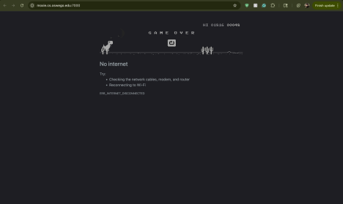

Bug/Defects
Bug/Defect # Defect 1
Severity: Low
STP Test Case # ST-2
Build/Release #: v0.1.0_20260304
Steps during test:
1. Open the Chrome browser on Windows OS
2. Navigate to the Homepage on the Moxie website
3. Inspected for a load event to be triggered
Description:
During FR-8.1/ST-2, when I opened the home page and refreshed it a few times, I didn’t notice any load event triggered or anything logging. (on the UI)

When Dev Inspect was open, an event was created but we’re still waiting for exact expectations on what we should see. Also, the time of the event is off by 4 hours (Event *Actual time: March 13th 8:38pm, *Time seen in log: March 14th 00:38am)
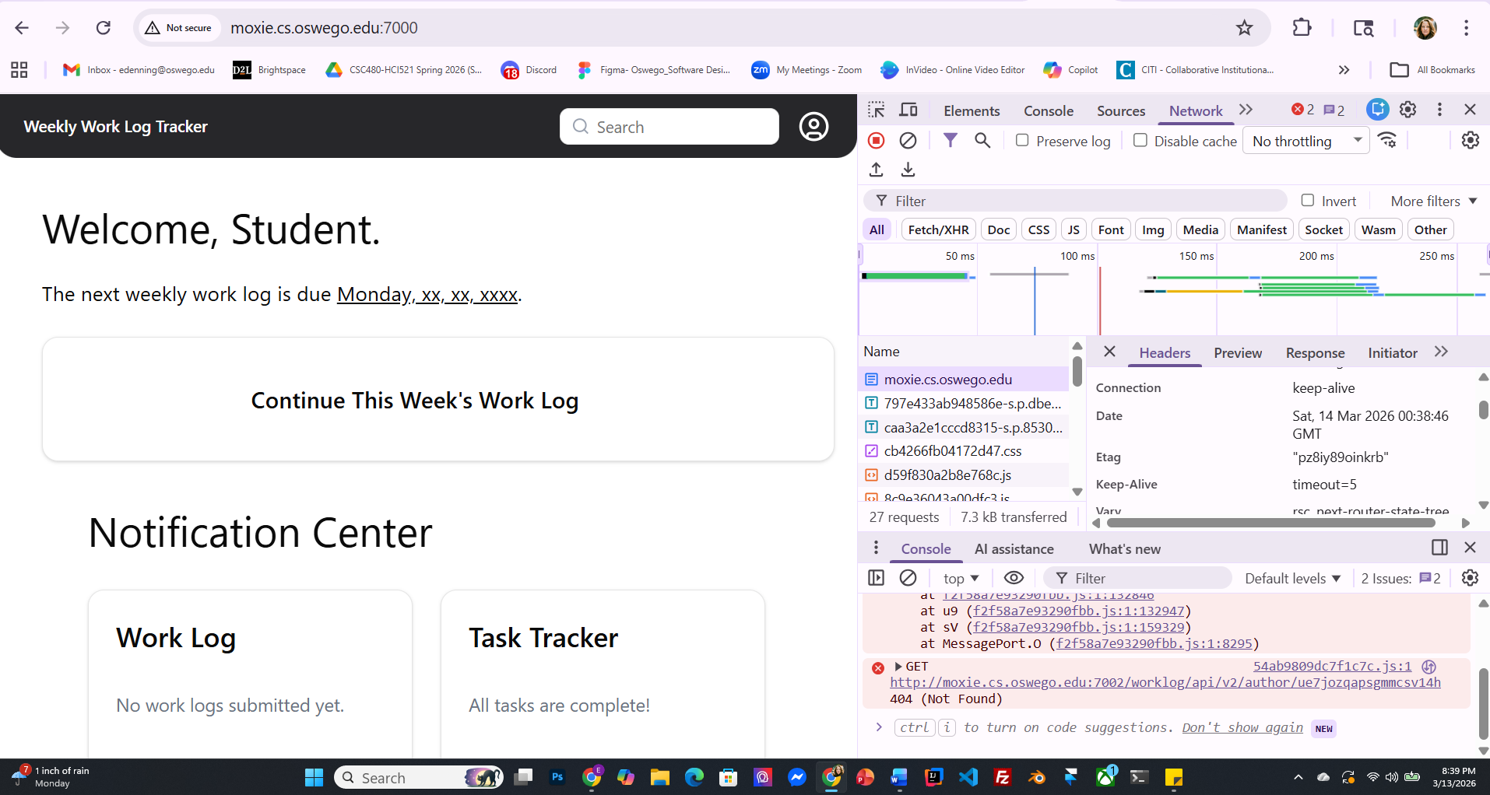
Potential Cause (if known): Not too sure.
Bug/Defect # Defect 2
Severity: Low
STP Test Case # ST-2
Build/Release # v0.1.0_20260304
Steps during test:
1. Open Chrome browser on MacOS
2. Loaded the home page
3. Turned off the wifi connection on my laptop
4. Refreshed
5. Turned the Wi-Fi back on
6. Inspected home page
Description:
During FR-8.2/ST-2, I turned off the Wi-Fi and saw the standard Chrome message that I can't access the website without an internet connection. When I turned it back on, it didn't log anything of an error or disconnection
Potential Cause (if known):
Don’t know
Screenshot:



